**Digital compass using Triple Axis Magnetometer**

Introduction

The unmanned machines like robots and drones cannot sense in which direction to move, unlike humans. Therefore, they need a sensor to identify directions. Therefore, we need magnetometers. They sense the magnetic field and based on this magnetic field; it tells the direction of a device in which this magnetometer is integrated. Hence, we can use HMC5883L to determine the direction of objects

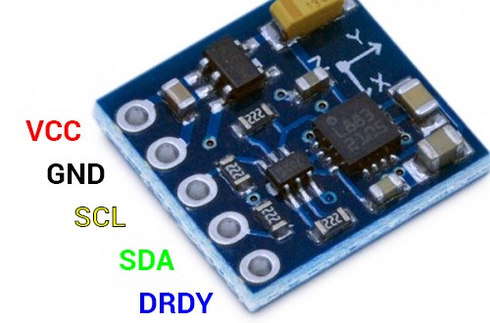

* **VCC**: Module power supply – 3 to 5 volts
* **GND:**Ground
* **SCL:**I2C Clock pin
* **SDA:**I2C Data pin
* **DRDY**(DataReady)**:**When the output value of the sensor is ready, an interrupt occurs in this pin. This pin is pulled up inside the module by default. When the output value of the module is ready, the pin is “0” for 250 microseconds.

Components

Arduino uno

GY-271 Magnetometer module(QMC5883L)

Breadboard

Connecting wires

Application

* GPS based wireless phones
* computer games
* wireless pointers
* sport watches

Objectives

Programming steps

1.install QMC5883L LIBRARY (<https://github.com/mprograms/QMC5883LCompass.git>)

2.Initialise variable to read compass value

3. read variable value x,y,z

4. open the serial monitor to display the compass output.

Program

// I2C Library

#include <Wire.h>

// QMC5883L Compass Library

#include <QMC5883LCompass.h>

QMC5883LCompass compass;

void setup() {

// Initialize the serial port.

Serial.begin(9600);

// Initialize I2C.

Wire.begin();

// Initialize the Compass.

compass.init();

}

void loop() {

int x, y, z;

// Read compass values

compass.read();

x = compass.getX();

y = compass.getY();

z = compass.getZ();

Serial.print("X: ");

Serial.print(x);

Serial.print(" Y: ");

Serial.print(y);

Serial.print(" Z: ");

Serial.println(z);

delay(300);

}

**Hardware**

**Instruction**

1.connect VCC and GND pin of HMC5883L module to Arduino uno board

2.connect serial clock pin to analaog input pin A5

3. connect serial data pin to analog input pin A4

